***Chemistry***

**8: Advanced Theories of Covalent Bonding**

**8.2: Hybrid Atomic Orbitals**

9. Why is the concept of hybridization required in valence bond theory?

Solution

Hybridization is introduced to explain the geometry of bonding orbitals in valance bond theory.

11. Explain why a carbon atom cannot form five bonds using *sp*3*d* hybrid orbitals.

Solution

There are no *d* orbitals in the valence shell of carbon.

13. A molecule with the formula AB3 could have one of four different shapes. Give the shape and the hybridization of the central A atom for each.

Solution

trigonal planar, *sp*2, trigonal pyramidal (one lone pair on A) *sp*3, T-shaped (two lone pairs on A*sp*3*d*, or (three lone pair on A) *sp*3*d*2

15. Sulfuric acid is manufactured by a series of reactions represented by the following equations: 





Draw a Lewis structure, predict the molecular geometry by VSEPR, and determine the hybridization of sulfur for the following:

(a) circular S8 molecule

(b) SO2 molecule

(c) SO3 molecule

(d) H2SO4 molecule (the hydrogen atoms are bonded to oxygen atoms)

Solution

(a) S8,each S has a bent (109°) geometry, *sp*3

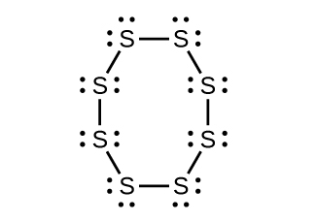

(b) SO2, bent (120°), *sp*2



(c) SO3, trigonal planar, *sp*2

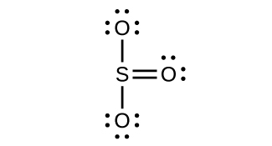

(d) H2SO4, tetrahedral, *sp*3

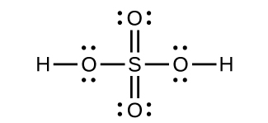

17. For many years after they were discovered, it was believed that the noble gases could not form compounds. Now we know that belief to be incorrect. A mixture of xenon and fluorine gases, confined in a quartz bulb and placed on a windowsill, is found to slowly produce a white solid. Analysis of the compound indicates that it contains 77.55% Xe and 22.45% F by mass.

(a) What is the formula of the compound?

(b) Write a Lewis structure for the compound.

(c) Predict the shape of the molecules of the compound.

(d) What hybridization is consistent with the shape you predicted?

Solution

(a) A 100-g sample contains 77.55 g Xe and 22.45 g F. Divide each mass by the atomic weight to find the number of moles. Then, compare the ratio of moles of the two elements.





Find the ratio by dividing by the smaller value.



That is, there are two atoms of F for each atom of Xe. Therefore, the empirical formula is XeF­2.

(b)

L:\Clients\Connexions\CONNEX130016_Chemistry\02_Working_Files\C08_Advanced Theories of Covalent Bonding\99_Current_Art\JPEG\CNX_Chem_08_02_xefluoride_img.jpg

(c) There are 22 electrons, 16 of which are used in the bond, leaving six electrons in the three pairs of unbonded electrons centered about the Xe. These unshared electrons are in a trigonal planar shape with the bonding pairs above and below the plane. Therefore, XeF2 is linear;   
(d) *sp*3*d* hybridization is consistent with the linear shape.

19. Strike-anywhere matches contain a layer of KClO3 and a layer of P4S3. The heat produced by the friction of striking the match causes these two compounds to react vigorously, which sets fire to the wooden stem of the match. KClO3 contains the  ion. P4S3 is an unusual molecule with the skeletal structure.

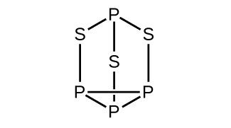

(a) Write Lewis structures for P4S3 and the  ion.

(b) Describe the geometry about the P atoms, the S atom, and the Cl atom in these species.

(c) Assign a hybridization to the P atoms, the S atom, and the Cl atom in these species.

(d) Determine the oxidation states and formal charge of the atoms in P4S3 and the ion.

Solution

(a)

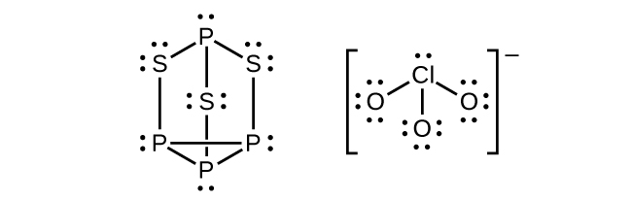

(b) P atoms, trigonal pyramidal; S atoms, bent, with two lone pairs; Cl atoms, trigonal pyramidal; (c) Hybridization about P, S, and Cl is, in all cases, *sp*3; (d) Oxidation states P +1, S , Cl +5,   
O –2.Formal charges: P 0; S 0; Cl +2: O –1

21. Write Lewis structures for NF3 and PF5. On the basis of hybrid orbitals, explain the fact that NF3, PF3, and PF5 are stable molecules, but NF5 does not exist.

Solution

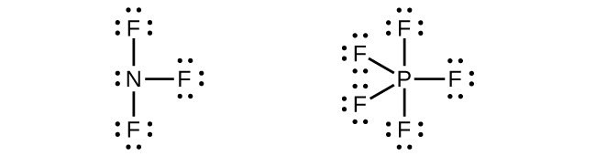

Phosphorus and nitrogen can form *sp*3 hybrids to form three bonds and hold one lone pair in PF3 and NF3, respectively. However, nitrogen has no valence *d* orbitals, so it cannot form a set of *sp*3*d* hybrid orbitals to bind five fluorine atoms in NF5. Phosphorus has *d* orbitals and can bind five fluorine atoms with *sp*3*d* hybrid orbitals in PF5.

This resource file is copyright 2015, Rice University. All Rights Reserved.